Required points:
- Please check that all required objects on BL_DM Layer have been created
- Grant all required privileges to BL_CL (Cleansing Layer). Check ‘Knowledge_Base.docx’ and ‘Naming_Conventions.docx’
- Create procedures/functions on BL_CL (one procedure = one dimension) to load dim data in DM layer.
Example of default procedures of dim tables with upsert do nothing
CREATE OR REPLACE PROCEDURE bl_cl.p_load_dim_discounts()
LANGUAGE plpgsql
AS $$
DECLARE
v_rows_inserted INTEGER := 0;
v_rows_skipped INTEGER := 0;
v_total_rows INTEGER := 0;
BEGIN
-- count all rows from source
SELECT COUNT(*) INTO v_total_rows FROM bl_3nf.ce_discounts;

-- insert new rows; on conflict do nothing
INSERT INTO bl_dm.dim_discounts (
discount_id,
discount_percentage,
discount_date,
source_id,
source_system,
source_entity,
ta_insert_dt,
ta_update_dt
)
SELECT
nextval('bl_dm.seq_dim_discount'),
discount_percentage,
discount_date,
source_id,
source_system,
source_entity,
CURRENT_DATE,
CURRENT_DATE
FROM bl_3nf.ce_discounts d
ON CONFLICT (source_id, source_system, source_entity)
DO NOTHING;

-- row count for inserted rows
GET DIAGNOSTICS v_rows_inserted = ROW_COUNT;

-- skipped rows = total rows - inserted rows
v_rows_skipped := v_total_rows - v_rows_inserted;

-- log event
CALL bl_cl.p_log_event(
'p_load_dim_discounts',
v_rows_inserted,
v_rows_skipped,
'SUCCESS',
'Inserted: ' || v_rows_inserted || ', Skipped: ' || v_rows_skipped
);

EXCEPTION
WHEN OTHERS THEN
CALL bl_cl.p_log_event(
'p_load_dim_discounts',
0,
0,
'FAIL',
SQLERRM
);
RAISE;
END;
$$;

- Every procedure must be repeatable, and no modifications should occur after multiple consecutive runs.
- Use composite types (One or more procedures)
- Use a cursor FOR loop
Created composite type for channel
Used with cursor for loop + upsert
- CREATE TYPE bl_cl.channel_type AS (
- channel_src_id VARCHAR(255),
- channel_name VARCHAR(64),
- channel_desc VARCHAR(255),
- source_system VARCHAR(255),
- source_entity VARCHAR(255)
- );

- CREATE OR REPLACE PROCEDURE bl_cl.p_load_dim_channels()
- LANGUAGE plpgsql
- AS
- $$
- DECLARE
- v_channel bl_cl.channel_type;
- v_rows_inserted INT := 0;
- v_rows_updated INT := 0;
- BEGIN
- FOR v_channel IN
- SELECT
- channel_src_id,
- channel_name,
- channel_desc,
- source_system,
- source_entity
- FROM bl_3nf.ce_channels
- LOOP
- -- upsert: inser on coflict update
- INSERT INTO bl_dm.dim_channels (
- channel_id,
- channel_src_id,
- channel_name,
- channel_desc,
- source_system,
- source_entity,
- ta_insert_dt,
- ta_update_dt
- )
- VALUES (
- nextval('bl_dm.seq_dim_channels'),
- v_channel.channel_src_id,
- v_channel.channel_name,
- v_channel.channel_desc,
- v_channel.source_system,
- v_channel.source_entity,
- CURRENT_DATE,
- CURRENT_DATE
- )
- ON CONFLICT (channel_src_id, source_system, source_entity) DO UPDATE
- SET
- channel_name = EXCLUDED.channel_name,
- channel_desc = EXCLUDED.channel_desc,
- source_system = EXCLUDED.source_system,
- source_entity = EXCLUDED.source_entity,
- ta_update_dt = CURRENT_DATE;

- -- count in case of update or insert
- IF EXISTS (
- SELECT 1
- FROM bl_dm.dim_channels
- WHERE channel_src_id = v_channel.channel_src_id
- AND ta_update_dt = CURRENT_DATE
- AND ta_insert_dt <> CURRENT_DATE -- this meant updated
- ) THEN
- v_rows_updated := v_rows_updated + 1;
- ELSE
- v_rows_inserted := v_rows_inserted + 1;
- END IF;
- END LOOP;

- -- log
- CALL bl_cl.p_log_event(
- 'p_load_dim_channels',
- v_rows_inserted,
- v_rows_updated,
- 'SUCCESS',
- 'Inserted: ' || v_rows_inserted || ', Updated: ' || v_rows_updated
- );

- EXCEPTION
- WHEN OTHERS THEN
- CALL bl_cl.p_log_event(
- 'p_load_dim_channels',
- 0,
- 0,
- 'FAIL',
- SQLERRM
- );
- RAISE;
- END;
- $$;

- Use EXECUTE for dynamic queries
Dynamic sql on all colums except date ones in load customers + upsert
- CREATE OR REPLACE PROCEDURE bl_cl.p_load_dim_customers()
- LANGUAGE plpgsql
- AS $$
- DECLARE
- v_customer RECORD;
- v_rows_inserted INTEGER := 0;
- v_rows_updated INTEGER := 0;

- v_sql TEXT;
- BEGIN
- FOR v_customer IN
- SELECT
- customer_src_id,
- first_name,
- last_name,
- phone_number,
- source_system,
- source_entity
- FROM bl_3nf.ce_customers
- LOOP
- -- Dynamic upsert using format + USING
- v_sql := format($f$
- INSERT INTO bl_dm.dim_customers (
- customer_id,
- customer_src_id,
- first_name,
- last_name,
- phone_number,
- source_system,
- source_entity,
- ta_insert_dt,
- ta_update_dt
- )
- VALUES (
- nextval('bl_dm.seq_dim_customers'),
- $1, $2, $3, $4, $5, $6,
- CURRENT_DATE, CURRENT_DATE
- )
- ON CONFLICT (customer_src_id, source_system, source_entity) DO UPDATE
- SET
- first_name = EXCLUDED.first_name,
- last_name = EXCLUDED.last_name,
- ta_update_dt = CURRENT_DATE
- $f$);

- EXECUTE v_sql
- USING
- v_customer.customer_src_id,
- v_customer.first_name,
- v_customer.last_name,
- v_customer.phone_number,
- v_customer.source_system,
- v_customer.source_entity;

- -- check if record was updated
- IF EXISTS (
- SELECT 1
- FROM bl_dm.dim_customers
- WHERE customer_src_id = v_customer.customer_src_id
- AND source_system = v_customer.source_system
- AND source_entity = v_customer.source_entity
- AND ta_update_dt = CURRENT_DATE
- AND ta_insert_dt <> CURRENT_DATE
- ) THEN
- v_rows_updated := v_rows_updated + 1;
- ELSE
- v_rows_inserted := v_rows_inserted + 1;
- END IF;
- END LOOP;

- -- log
- CALL bl_cl.p_log_event(
- 'p_load_dim_customers',
- v_rows_inserted,
- v_rows_updated,
- 'SUCCESS',
- 'Inserted: ' || v_rows_inserted || ', Updated: ' || v_rows_updated
- );

- EXCEPTION
- WHEN OTHERS THEN
- CALL bl_cl.p_log_event(
- 'p_load_dim_customers',
- 0,
- 0,
- 'FAIL',
- SQLERRM
- );
- RAISE;
- END;
- $$;

- Use Upsert (merge or insert on conflict) (One or more procedures).

load_channel
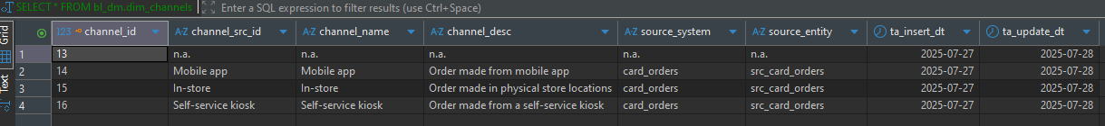
Load customers
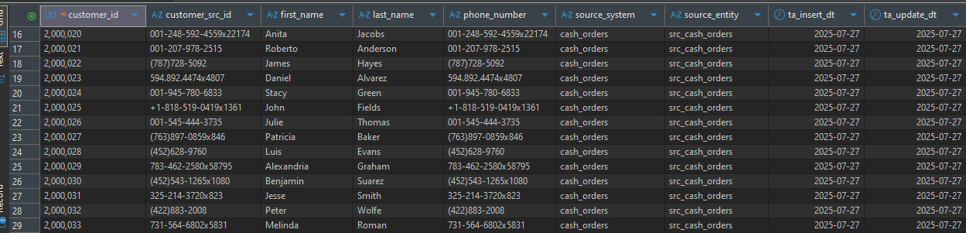
Load employee
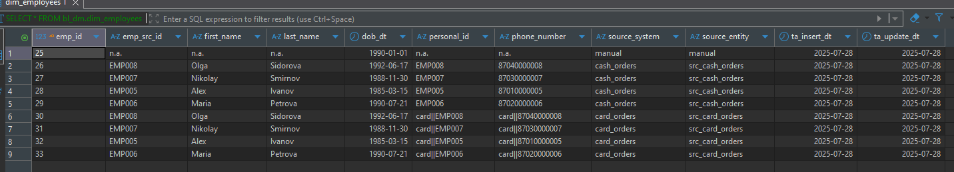
Load discounts
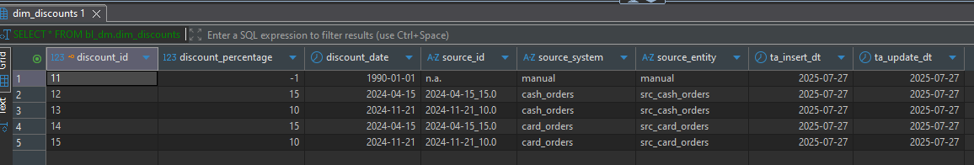
Load card info
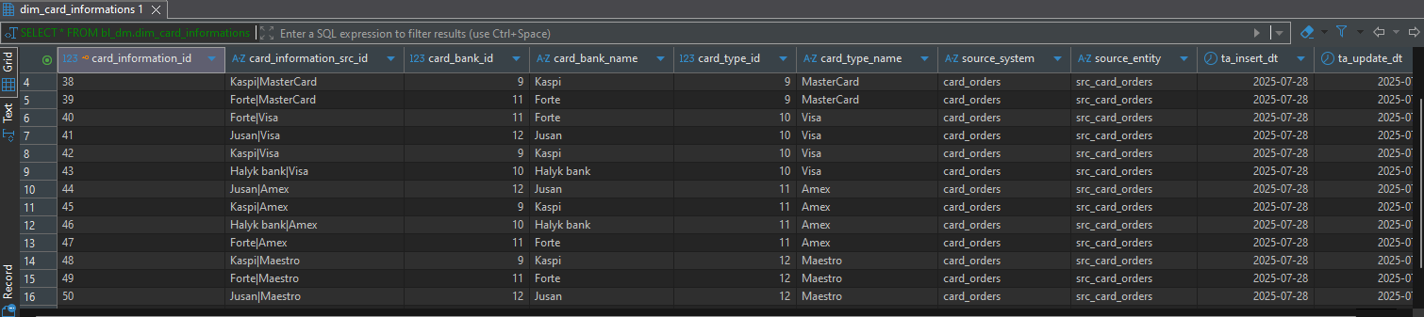
Load point location
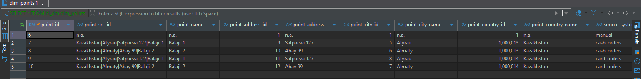
So here is the log of load
at the initial I was just testing you can see there
dim channels 4 and next row 4 I did truncate there
employees 9 9 9 here I was adding update(it was do nothing initially) and then realized that every time it will be updated so never will be skipped cause I was doing it with same data.
After some improvements all of them are 0 when procedures are called, so nothing inserted only updated cause every time on conflict do update was triggeres and skipped ones are for do nothing.
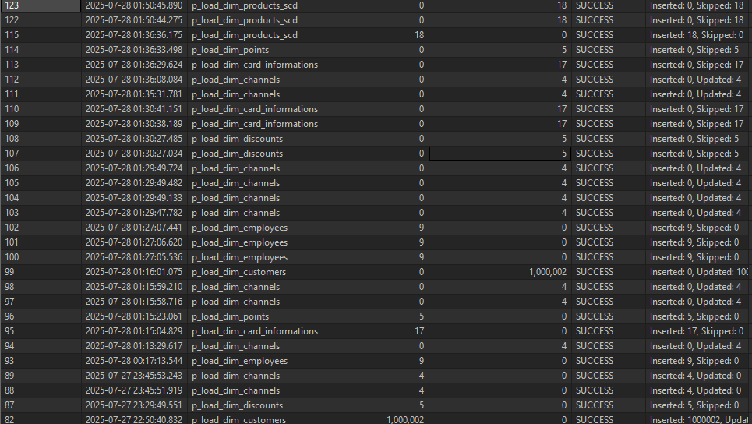

card src
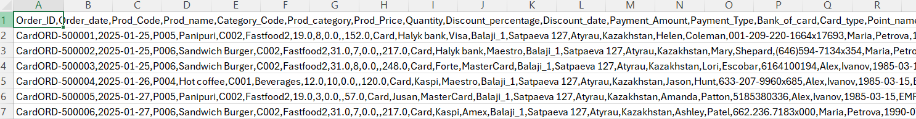
new data changed fastfood->fastfood2 ; sandwich->sandwich burger2

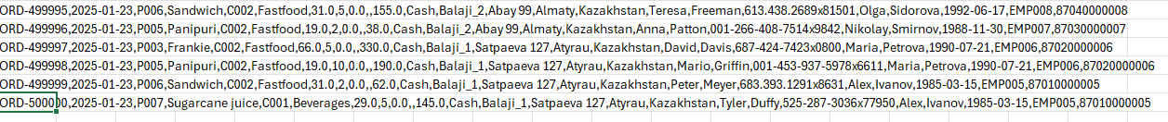
cash src
new data changed sandwicg->sandwich burger2; fastfood->fastfood2
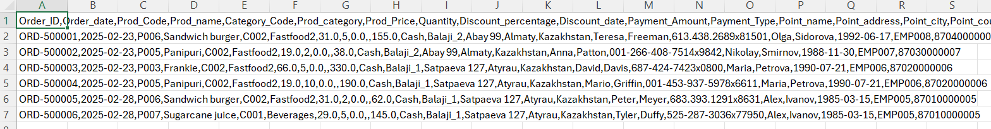

BL3_NF Before new data loaded
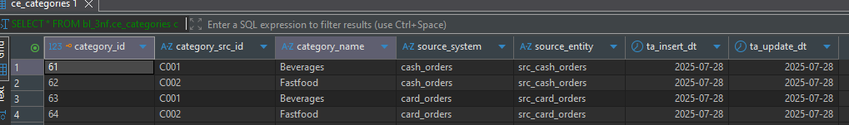
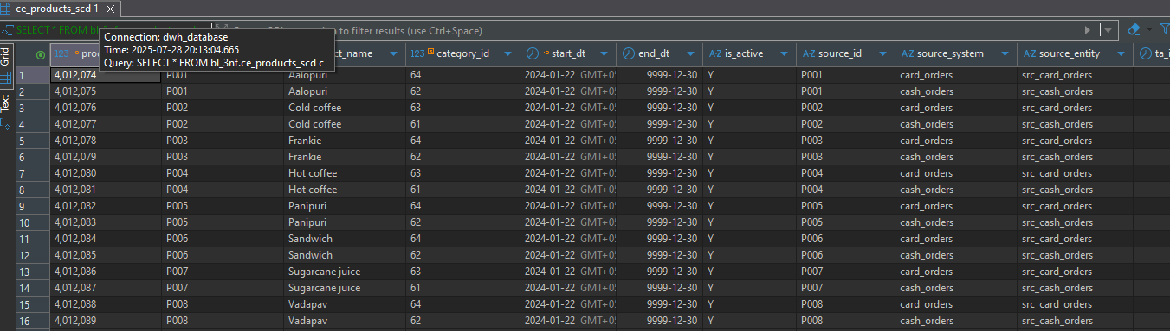

After new data loaded
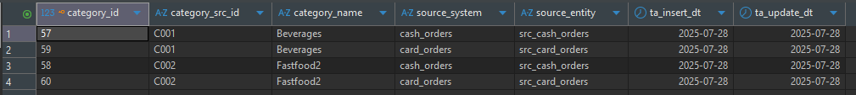
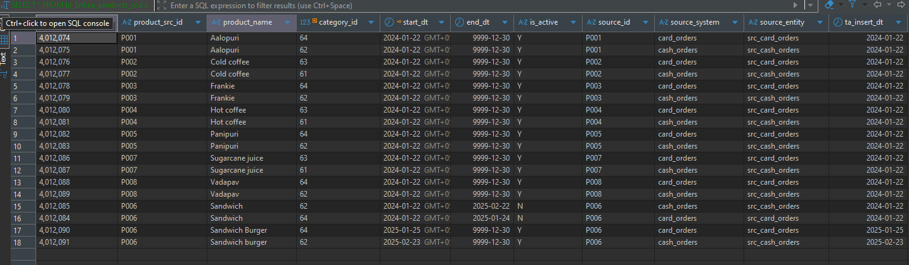
Log
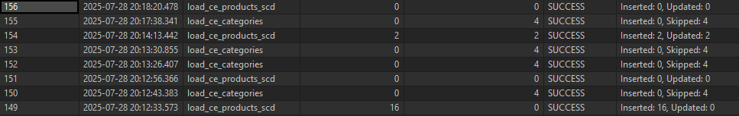
Load into products_scd
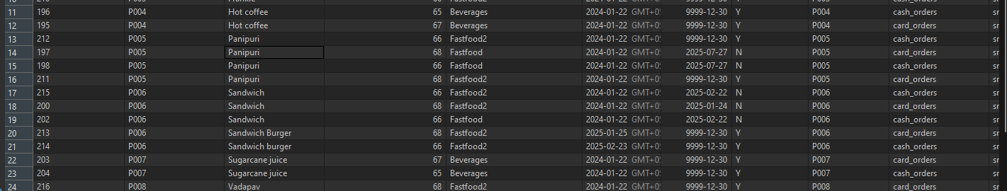
So, here is my product scd of dim and problem about category cause if I will update I cannot update my product scd dim in proper way because I am taking new data from category by its update_dt and it will cause some problems later but I think if load will by incremental normally one by one it will not cause such a problem. But in my case my data are done by bulk load at initial point.
Please ignore my fct of dim tables I will do it in proper way in task 9.

